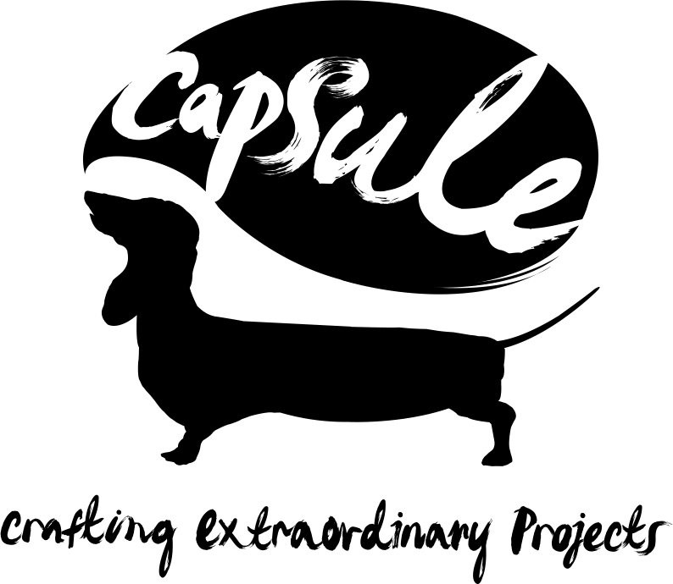

**Home of Metal - Project Coordinator**

(Freelance Role)

**90 days between February – October 2019 based on 2-3 days per week with possible extension**

**Fee: £110 per day   
Employer:** Capsule  
**Location of post:** **Custard Factory Birmingham  
Closing date:** 5pm Friday 25th January 2019 **Interview date:** Friday 1st February 2019

We are an equal opportunity employer and value diversity at our organisation. We do not discriminate on the basis of race, religion, colour, national origin, gender, sexual orientation, age, marital status, or disability status.

**Role:**

Capsule are looking for a highly organized, motivated, freelance coordinator to work on our Home of Metal project. They should have experience in working on arts and cultural events or heritage, marketing and project management, linked to audience development and community engagement. This is a unique opportunity to work with Home of Metal in Birmingham to deliver our highly ambitious 2019 programme.

The successful candidate must be able to multitask, coordinate and manage a variety of projects throughout the programme. They should have strong knowledge and experience of administrative systems, delivering complex programmes and a strong knowledge of online marketing tools and digital media in order to cover the breadth of activity which will range from the recruitment and training of volunteers to new contemporary art commissions delivered with major institutions.

**Background and context:**

*“Heavy Metal was born in the West Midlands and has developed a global following matched only by hip-hop. It’s time to stop sneering and celebrate this proud cultural heritage.”* New Statesman.

Home of Metal is a Capsule project and a celebration of the music that was born in Birmingham. Music that turned up the volume, down-tuned the guitars, and introduced a whole new meaning to the word ‘heavy’.  Home of Metal’s exhibitions and events join the dots between music, social history, visual art and fan cultures to produce a new perspective on Heavy Metal; one that is celebratory, eschews notions of high/low art and joins audiences and performers together.

Home of Metal will deliver a programme of activity during summer 2019 including a major exhibition at Birmingham Museum & Art Gallery and exhibitions at The New Art Gallery Walsall, MAC and Eastside Projects. Home of Metal is supported by Arts Council England, Heritage Lottery Fund, Birmingham City University and a range of project partners and supporters.

**You will be responsible for:**

* Acting as the main point of contact for exhibition contributors, volunteers and venues for the Home of Metal programme.
* Overseeing the logistics of the events, including sourcing materials and preparing briefs for any volunteers.
* Assisting in the day-to-day running of Home of Metal including maintaining a calendar and project planning timeline and maintaining contacts with partners and venues.
* Assisting with monitoring and evaluating projects including recording all data relating to participation, engagement and attendance.
* Creating Inventory Lists of exhibition objects for Birmingham Museum & Art Gallery.
* Arranging appointments, lists of collections, photography and transport to and from contributors to the exhibitions
* Drafting and/or proofing copy, developing content for the HoM website and socials and identifying content from the archive as and when required.
* Supporting associate activities ie the exhibition and symposium at Birmingham City University.
* Coordinating distribution and display of marketing materials in collaboration with venues.
* Arranging Volunteer recruitment and training, monitoring their learning and any specific needs/requirements.
* Coordinating the project database of professional contacts and ensuring the list is compatible with the audience database and appropriate for each event.
* Managing the HoM email account and answering any enquiries via email.
* Representing HoM at networks and meetings as and when required.
* Undertaking all other appropriate duties for the effective administration and operation of the project as required by the Director.

**Experience & Skills:**

* Working within the arts, cultural or heritage sectors.
* Excellent and demonstrable project management/event coordination skills and the ability to hit the ground running.
* Excellent communication skills, both written and oral.
* Good organisational skills, prioritisation and problem solving.
* IT skills, especially strong use of Excel and a good knowledge of social media platforms and their function.
* Interest in people, their interests and sharing passions.

**Personal Profile:**

We are looking to appoint a warm and welcoming team player who likes working with people in an engaging way, who is assertive when dealing with challenging situations and is flexible, pragmatic and resourceful in coordinating and delivering projects.

**Essential:**

* Be resourceful, level headed and be able to work well under pressure
* Be passionate about creating art events that reach out to a range of audiences.
* Be self-motivated and be prepared to work flexibly and sometimes unsociable hours during project delivery
* Be a team player and thrive on supporting the team
* Have a positive and confident attitude.

**Desirable:**

* An interest in contemporary music, arts, festivals, digital and live events.
* Driver with full UK license and own car
* Advanced IT skills including both creative and practical software applications
* First aid training.

For further information about Home of Metal please visit www.homeofmetal.com

**If you are interested in applying for this opportunity please email your cv, a letter of application outlining why you are interested in this opportunity and how you feel you would fulfil this role (no more than 2 sides of A4) + fill out our Equal Opportunities Form to: nicola@capsule.org.uk**

**DEADLINE 5pm, 25 January 2019.**